1. OPEN PRIVATE WINDOW IN CHROME OR EDGE BROWSER OR PRIVATE INCOGNITO WINDOW type [www.outlook.com](http://www.outlook.com) Please Create New outlook email ID – Example – [Firstnameaz800@OUTLOOK.COM](mailto:Firstnameaz800@OUTLOOK.COM) From EDGE OR Chrome and Make sure you are using a Private or Incognito window.
2. **\*\*\* EXISTING OUTLOOK MAIL ID WILL NOT WORK . THIS IS MOST IMPORTANT \*\*\*\***
3. **THIS PASS WILL GET 100 USD CREDIT WITH 1 MONTH VALIDITY . Pls do labs and delete resource group so that we can utilize all credit in whole month.**
4. Pls save email ID and Password in safe place- Desktop notepad some where.
5. In same private window> OPEN NEW TAB – SECOND TAB IN SAME PRIVATE WINDOW

### Step 1: Redeeming a Microsoft Azure Pass Promo Code:

* Open a browser and navigate to: www.microsoftazurepass.com

It is recommended you close all browsers and open a new In-Private Browser session. Other log-ins can persist and cause errors during the activation step.

* Click the start button to get started.

# a Microsoft Azure Pass Subscription

### Creating an Azure Pass subscription is a two step process.

1. Redeem your Azure Pass Promo Code
2. Activate your subscription

### Step 1: Redeeming a Microsoft Azure Pass Promo Code:

* Open a browser and navigate to: www.microsoftazurepass.com

It is recommended you close all browsers and open a new In-Private Browser session. Other log-ins can persist and cause errors during the activation step.

* Click the start button to get started.

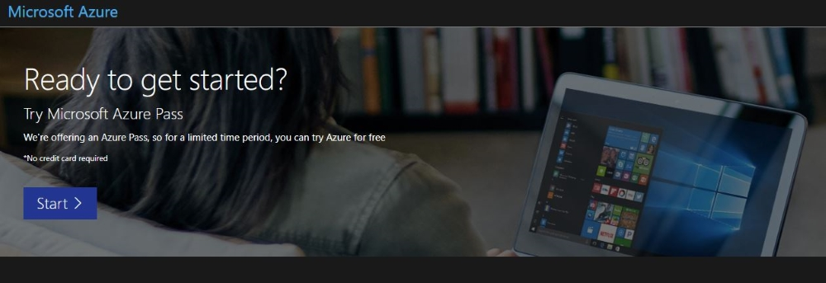

* Enter your account login information and select “Sign In”.

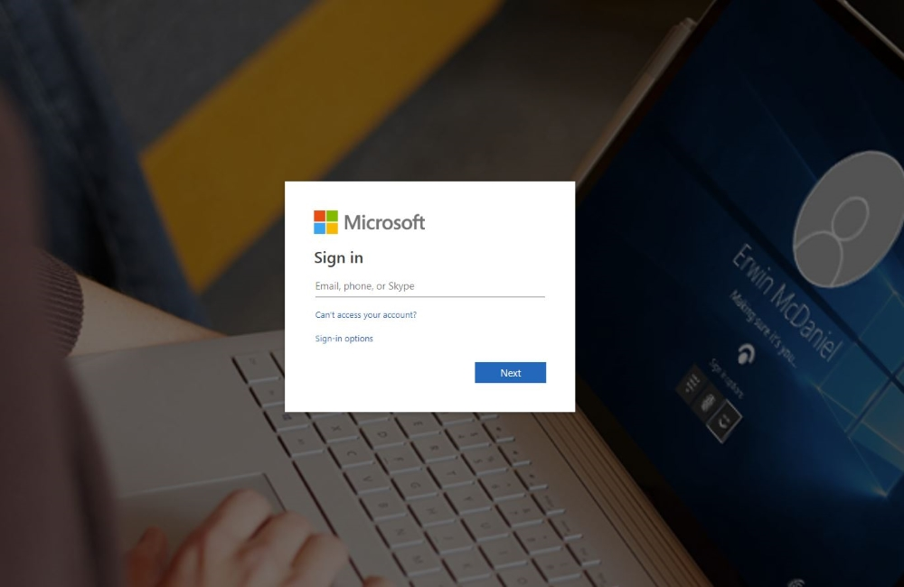

* Click “Confirm” if the correct email addrdess is listed.Logio

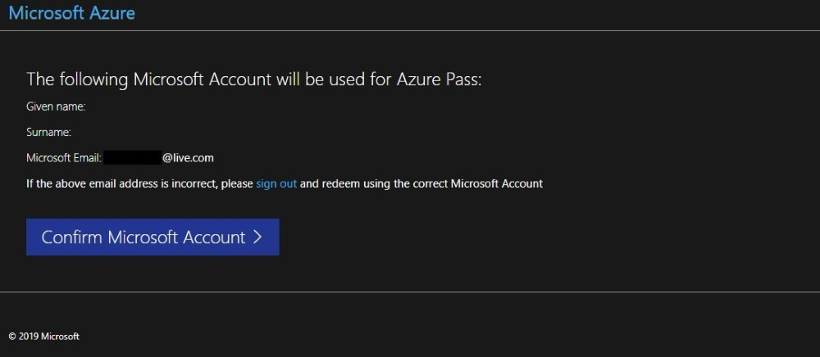

* Enter your promo code in the Promo code box and click “Claim Promo Code”.

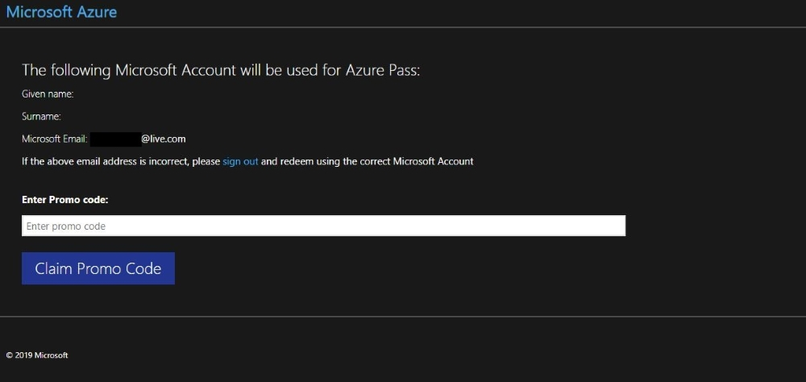

Ple

* It spSmay take up to 5 minutes to process the redemption.

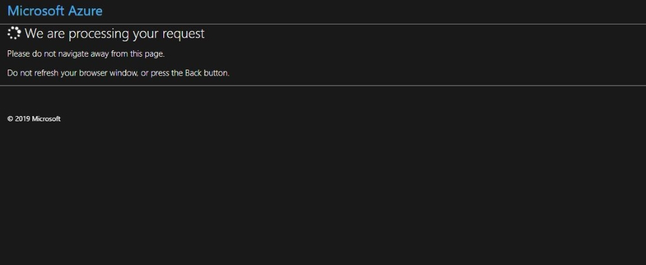

### Step 2: Activate ydddouPleaser subscription:

* When the redemption process is completed, it will redirect to the sign up page.
* Enter your account information and click “Next”.

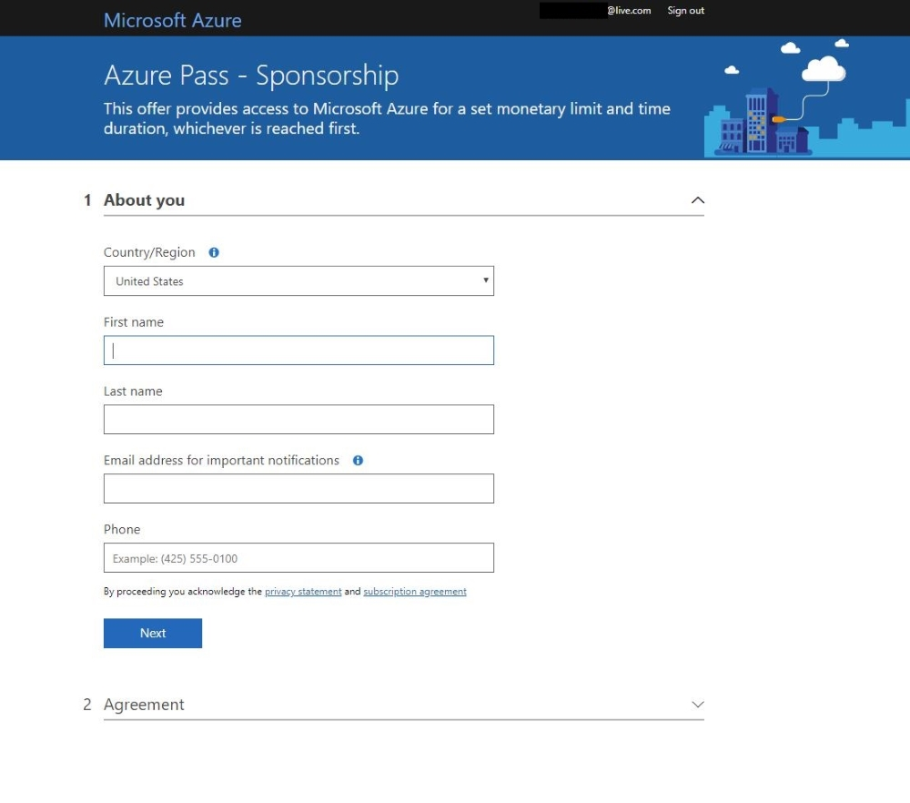

* Click the agreement check box and click the Sign up button.
* It may take a few minutes to process the request.

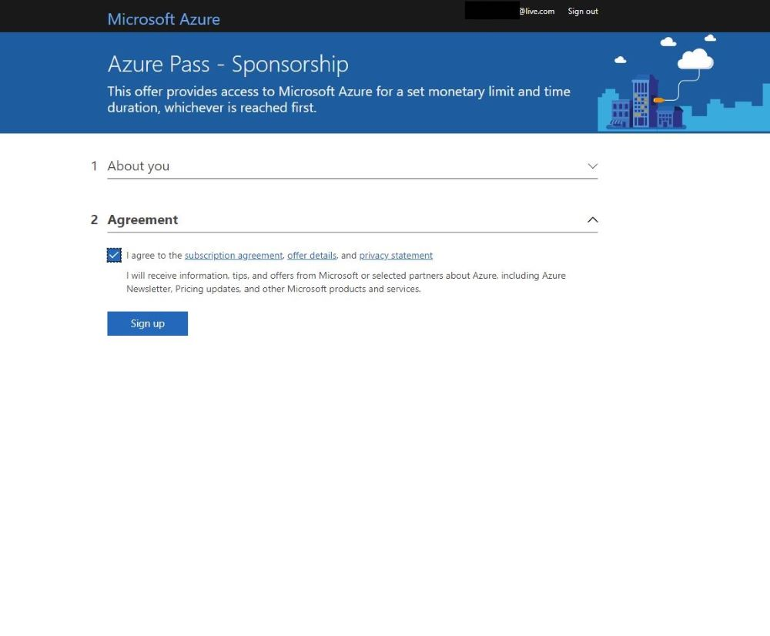

* Your Azure subscription is ready
* AFTER SIGN UP ,FDD

After sign up , wait for 3-5 minutes and wizard automatically redirected to portal.azure.com. During this 3 minutes please do not Refresh your browser , wait till it will redirected to AZ Portal.

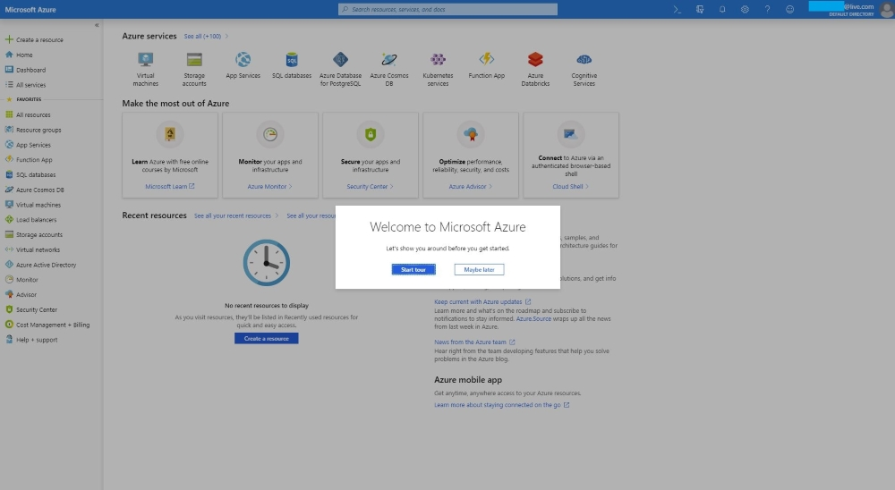

* You can check the balance of your Azure Pass Credits on <https://www.microsoftazuresponsorships.com/balance>

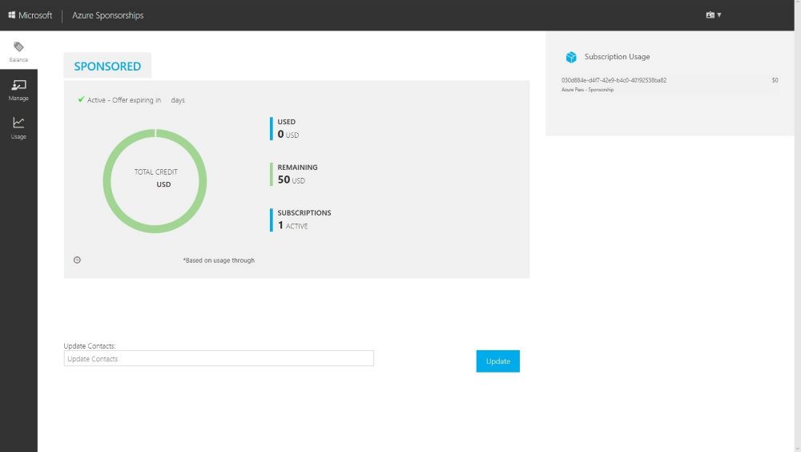

© 2021 Microsoft

[Support |](https://ms.portal.azure.com/#blade/Microsoft_Azure_Support/HelpAndSupportBlade/newsupportrequest)[Privacy & Cookies |](https://go.microsoft.com/fwlink/?LinkId=248681)[Terms of Use](https://azure.microsoft.com/en-us/support/legal/website-terms-of-use/)

1. Validation – Portal.azure.com > Search – Subscription >

Here you will see Azure-Pass – Active.